Animals often transition between wakefulness and sleep stages as a necessary step for survival. Sleep serves many physiological functions, such as waste clearance, restoration, memory processing, etc [1]. Many neurotransmitters control the transitions between sleep and wakefulness, including serotonin, norepinephrine, and histamine. Dopamine (DA) is a neurotransmitter that has been shown to play a large role in motor control [2]. Right now, the Gradinaru lab is investigating if Dopamine neurons that are located in the Dorsal Raphe Nucleus (DRN) play a role in inducing sleep or wakefulness, and particularly whether DRN DA neurons are sufficient enough to change from sleep to awake or vice versa. The technique they use for this is optogenetics, which uses light to deliver viral agents to the eye in order to inhibit or activate the expression of DRN DA in optical neurons.

Currently, to do the experiment, the Gradinaru lab must know in real-time when their mice are asleep, and if so, which sleep state they are in (REM sleep or Non-REM sleep). For the SURF project, I am developing a software that takes in EEG and EMG channels from the mice and uses machine learning to determine the sleep state in real time via unsupervised clustering methodologies. This is a problem that has been tackled by many researchers, but so far, there has not been a “best way” to classify sleep states automatically. The methodologies vary greatly in complexity. One paper uses simple thresholds to determine the sleep states, where each threshold was determined by looking at the data manually [3]. Another paper takes the entire EEG and EMG signals, extracts features through Principal Component Analysis to reduce the dimensionality of the data, and uses non-parametric density based clustering to cluster the data into the different behavior states [4]. All of these papers have roughly the same steps to approaching the problem. They reduce the dimensionality of the time-series data through extracting certain features and then cluster the data into the three states using either supervised or unsupervised learning methods. So far, I have been experimenting with different feature extractions and clustering algorithms.

The features I have implemented thus far are: delta power, theta power, delta/theta power ratio, total EMG power, pseudo-Approximate Entropy metric (taken from a paper [5] that uses an entropy-like metric for classification), median EMG amplitude, ratio between large and small EEG wave-lengths, and number of sign inversions in the time-series. I ran an Analysis of Variance on each feature to see how well they distinguish among the three states (REM, NREM, and Wake).

|  |  |  |
| --- | --- | --- |
| Feature | F value | p value |
| Delta Power | 2705.78 | 0.0 |
| Theta Power | 1440.078 | 0.0 |
| Delta/Theta Power Ratio | 1218.75 | 0.0 |
| EMG Power | 1812.52 | 0.0 |
| Pseudo Approximate Entropy | 208.235 | 3.92e-87 |
| EMG Median Amplitude | 218.809 | 2.55e-91 |
| EEG Large-Small Wavelength Ratio | 3573.69 | 0.0 |
| Sign Inversions | 4950.36 | 0.0 |

**Figure 1.** Feature ANOVA tests that tested difference in means across Wake, NREM, and REM states.

Note: a p-value of 0.0 means that the p-value is so little that it can be considered as 0.

From this data, it would seem that these features would perform very well in separating the different behavior states. However, when running the k-means unsupervised clustering algorithm on these features to cluster the data, the results were thrown off by outliers:

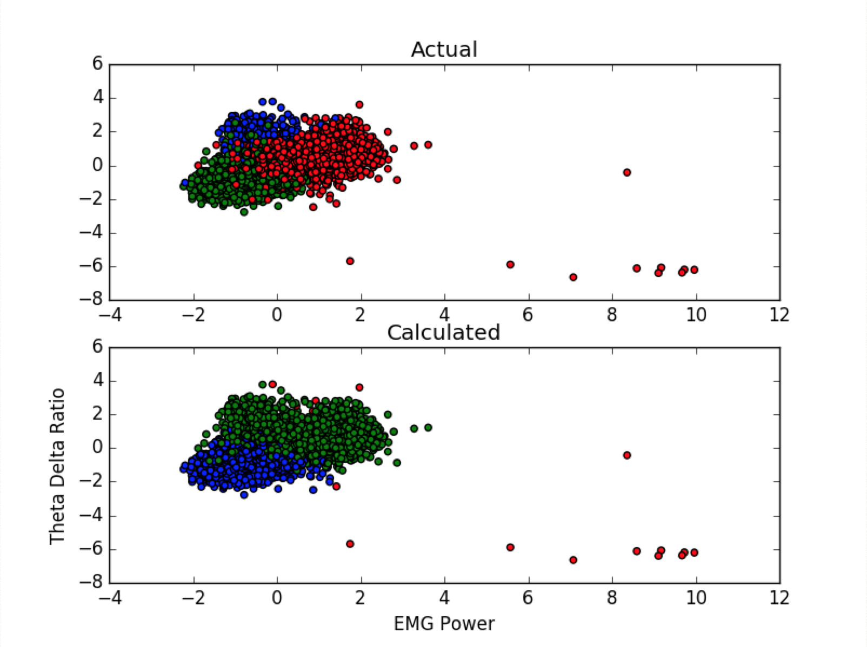

**Figure 2.** k-means clustering plot for two of the features. The algorithm was run on all features, but only two dimensions are shown. Features were normalized through z-scores before running. In the actual plot, red is Wake, green is NREM, and blue is REM.

The outliers that were greater than 4 standard deviations were clustered as a state all by themselves, resulting in a poor clustering of the stages. This clustering was redone with outliers greater than four standard deviations being left out of the classification (instead, they were given random states):

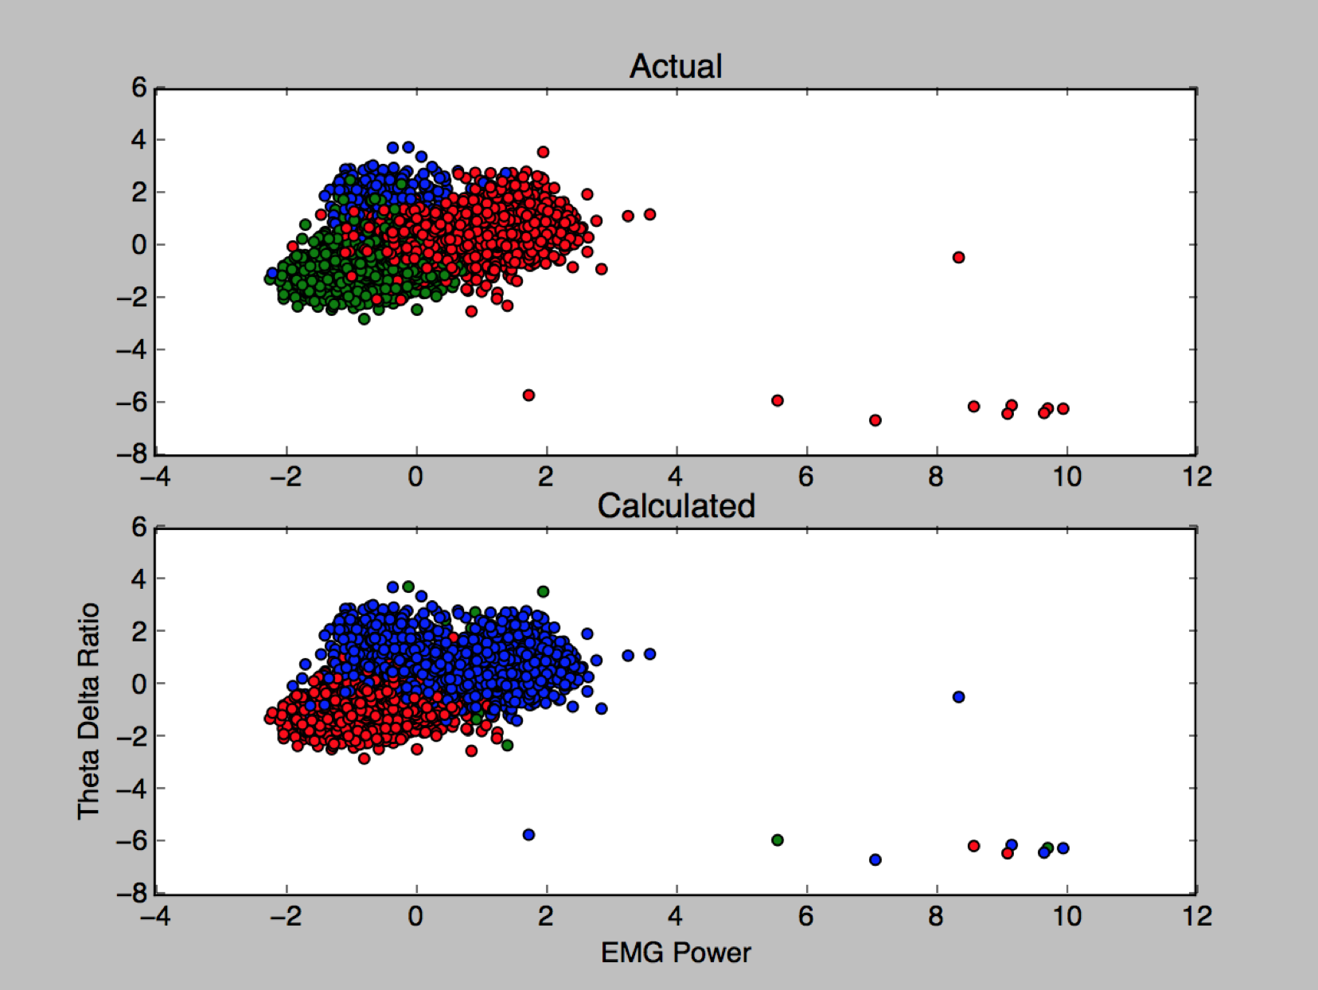

**Figure 3.** k-means clustering plot with outliers taken out of classification and instead given random states.

This clustering was a bit better. However, even though the REM stages occurring about 10% of the time, the clustering algorithm picked up only a few points as REM sleep. It was suspected that this was because the features were not separating REM very well from the other two states. Post-hoc ANOVA tests were run to see how different the respective means were in REM stages and NREM/Wake stages:

|  |  |  |
| --- | --- | --- |
| Feature | F value | p value |
| Delta Power | 296.77 | 2.06e-64 |
| Theta Power | 17.76 | 2.56e-05 |
| Delta/Theta Power Ratio | 793.63 | 1.11e-160 |
| EMG Power | 55.66 | 1.034e-13 |
| Median EMG Amplitude | 317.78 | 1.092e-68 |
| EEG Large-Small Wavelength Ratio | 59.383 | 1.59e-14 |
| Sign Inversions | 34.55 | 4.466e-09 |

**Figure 4.** Post-hoc ANOVA test statistics that was run on the REM group and the NREM+Wake group for each feature.

Even though the features statistically significantly can separate REM from NREM+Wake, the F-values are nowhere near as strong as the previous ANOVA results that tested difference in means across all three states. This most likely means that more features with better REM indicators should be calculated in order to be able to classify more REM occurrences. Although it may have been possible that the k-means algorithm was not appropriate for this data, this was accounted for by testing with other unsupervised methods (Density Based Clustering and Gaussian Mixture). These algorithms returned similar results.

For comparison, a supervised learning algorithm was applied to the data, decision tree. The parameters were fine-tuned to prevent overfitting of the data (splitting metric was changed to Shannon Entropy and maximum tree depth was restricted to three nodes). This worked well as the classification had 90% accuracy. Below is a plot of the classification:

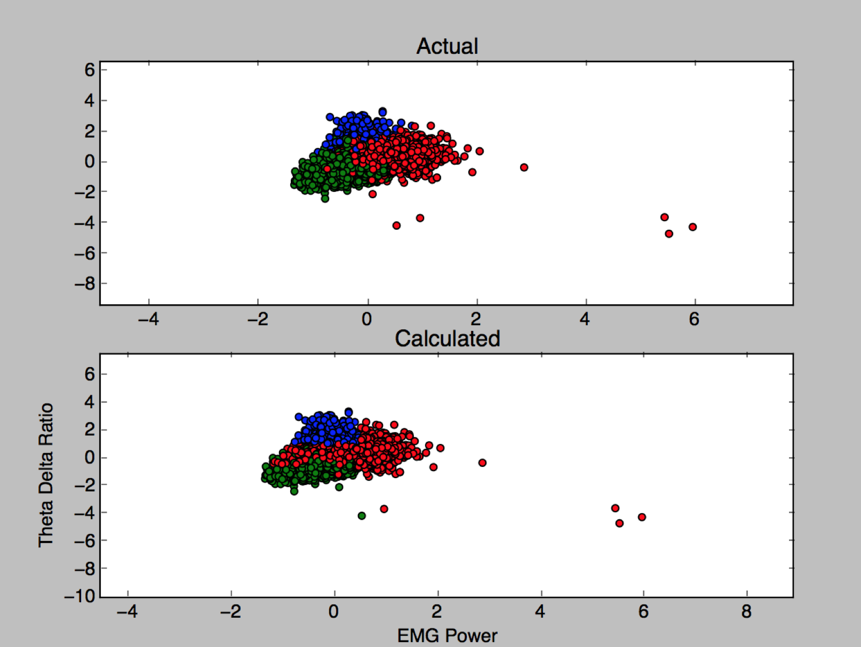

**Figure 5.** Plot of results from decision tree classification. Though all features were used, only two dimensions are shown. The actual and calculated classes look very identical.

Thresholds for splitting were fine-tuned to bias towards detecting REM states, since the REM data is currently more valuable so false-positives can be tolerated in exchange for a greater chance in detecting REM. This decision tree performed well for the other subjects as well. From this, it can be concluded that a supervised method with these features would require little training data to perform well in classification. However, an unsupervised method would require further research in finding new features that differentiate REM points better.

In the future, I will be researching more features and experimenting their performance in unsupervised clustering. I will also be experimenting with multiple unsupervised algorithms, and possibly supervised algorithms, to optimize accuracy and computational efficiency. Once this is done, I will be working on implementing these to detect the states in real-time overnight without any experimenter’s supervision.

**References**

1. Brown RE et al., Control of sleep and wakefulness, *Physiol Rev* 2012, 92: 1087-1187.

2. Bromberg-Martin ES et al., Dopamine in motivational control: rewarding, aversive, and alerting. *Neuron* 2010, 68(5): 815-834.

3. Weber, F., Chung, S., Beier, K. T., Xu, M., Luo, L., & Dan, Y. (2015). Control of REM sleep by ventral medulla GABAergic neurons. *Nature,* *526*(7573), 435-438. doi:10.1038/nature14979

4. Sunagawa, G. A., Séi, H., Shimba, S., Urade, Y., & Ueda, H. R. (2013). FASTER: An unsupervised fully automated sleep staging method for mice. *Genes to Cells Genes Cells,* *18*(6), 502-518. doi:10.1111/gtc.12053

5. White, A. M., Williams, P. A., Ferraro, D. J., Clark, S., Kadam, S. D., Dudek, F. E., & Staley, K. J. (2006). Efficient unsupervised algorithms for the detection of seizures in continuous EEG recordings from rats after brain injury. *Journal of Neuroscience Methods,152*(1-2), 255-266. doi:10.1016/j.jneumeth.2005.09.014